

**Department of Computer Science and Engineering**

**School of Engineering**

# PRESIDENCY UNIVERSITY BANGALORE

**HTML MINI PROJECT**

***Submitted by***

**K Guru Sasi Kumar – 20201ISI0006**

**Rishabh Maddesiya – 20201ISI0007**

**Hima Nagasai Manoj Gorla– 20201ISI0012**

**E Arjun Kumar – 20201IST0010**

**Himanshu V – 20201IST0056**

**Abstract**

Music is an important part of many cultures, and has long been used to express emotion and tell stories. Music can be used to create a mood or atmosphere, and is often used to accompany other activities, such as dancing or meditation. It can also be used to help people relax or energize.

Music speaks where words fail.

Create a music web page using HTML/CSS/JAVASCRIPT for development of web page. Design a page that provides music.

**1.HTML**

<html>

<title>

gṛhāḥ music page

</title>

<head>

<link rel="stylesheet" href="[mystyle.css](view-source:file:///C:/Users/himan/OneDrive/Desktop/html%20pjt/mystyle.css)">

<style>

* {

margin:0;

padding:0;

box-sizing: border-box;

font-family: Monotype Corsiva;

}

body{

display: flex;

justify-content: center;

align-items: center;

height: 100vh;

background-color: #151925;

font-family: sans-serif;

font-weight: bold;

}

a

{

position: relative;

display: inline-block;

padding:25px 15px;

margin:20px 10px;

color: #03e9f4;

text-decoration: none;

text-transform: uppercase;

transition: 0.9s;

/* letter-spacing: 2px; */

overflow: hidden;

margin-right:20px;

}

a:hover

{

background: #03e9f4;

color: #050801;

box-shadow: 0 0 5px #03e9f4, 0 0 25px #03e9f4, 0 0 50px #03e9f4, 0 0 200px #03e9f4;

-webkit-box-reflect:below 1px linear-gradient(transparent, #0005);

}

a:nth-child(1)

{

filter:hue-rotate(270deg);

}

a:nth-child(2)

{

filter:hue-rotate(110deg);

}

a:nth-child(3)

{

filter:hue-rotate(200deg);

}

a:nth-child(4)

{

filter:hue-rotate(270deg);

}

a:nth-child(5)

{

filter:hue-rotate(110deg);

}

a:nth-child(6)

{

filter:hue-rotate(186deg);

}

a span

{

position: absolute;

display:block;

}

a span:nth-child(1)

{

top:0;

left:0;

width:100%;

height:2px;

background: linear-gradient(90deg, transparent,#03e9f4);

animation: animate1 1s linear infinite;

}

@keyframes animate1

{

0%{left:-100%;}

50%,100%{left:100%;}

}

a span:nth-child(2)

{

top:-100%;

right:0;

width:2px;

height:100%;

background: linear-gradient(180deg, transparent,#03e9f4);

animation: animate2 1s linear infinite;

animation-delay: 0.25s;

}

@keyframes animate2

{

0%{top:-100%}

50%, 100%{top:100%;}

}

a span:nth-child(3)

{

bottom:0;

right:0;

width:100%;

height:2px;

background: linear-gradient(270deg, transparent,#03e9f4);

animation: animate3 1s linear infinite;

animation-delay: 0.5s;

}

@keyframes animate3

{

0%{right:-100%}

50%, 100%{right:100%;}

}

a span:nth-child(4)

{

bottom:-100%;

left:0;

width:2px;

height:100%;

background: linear-gradient(360deg, transparent,#03e9f4);

animation: animate4 1s linear infinite;

animation-delay: 0.75s;

/* border-radius:20px; */

}

@keyframes animate4

{

0%{bottom:-100%}

50%, 100%{bottom:100%;}

}

</style>

</head>

<body background="[m1.jpeg](view-source:file:///C:/Users/himan/OneDrive/Desktop/html%20pjt/m1.jpeg)">

<form action="[3.html](view-source:file:///C:/Users/himan/OneDrive/Desktop/html%20pjt/3.html)">

<h><font size="10ppx" color="white">Music</h>

<table>

<tr>

<th>

<a><font color="#1af4d8" size="3ppx">

<span></span>

<span></span>

<span></span>

<span></span>

20201ISI0006 <BR> GURU SASI KUMAR K

</a>

</th>

</tr>

<tr>

<th>

<a><font color="#d9cc1e" size="3ppx">

<span></span>

<span></span>

<span></span>

<span></span>

20201ISI0007 <BR> RISHAB M

</a>

</th>

</tr>

<tr>

<th>

<a><font color="white" size="3ppx">

<span></span>

<span></span>

<span></span>

<span></span>

20201ISI0012 <BR> HIMA NAGASAI MANOJ G

</a>

</th>

</tr>

<tr>

<th>

<a><font color="orange" size="3ppx">

<span></span>

<span></span>

<span></span>

<span></span>

20201IST0010 <BR> ARJUN KUMAR E

</a>

</th>

</tr>

<tr>

<th>

<a><font color="silver" size="3ppx">

<span></span>

<span></span>

<span></span>

<span></span>

20201IST0056 <BR> HIMANSHU V

</a>

</th>

</tr>

<style>

.button_t{

background-color: aqua;

color: blue;

}

.input_b{

background-color: darkgray;

color: black;

}

</style>

</head>

<body>

<button type="submit" class="button_t" style="width:60px ; height:30px" >

&#9658;

</body>

</html>

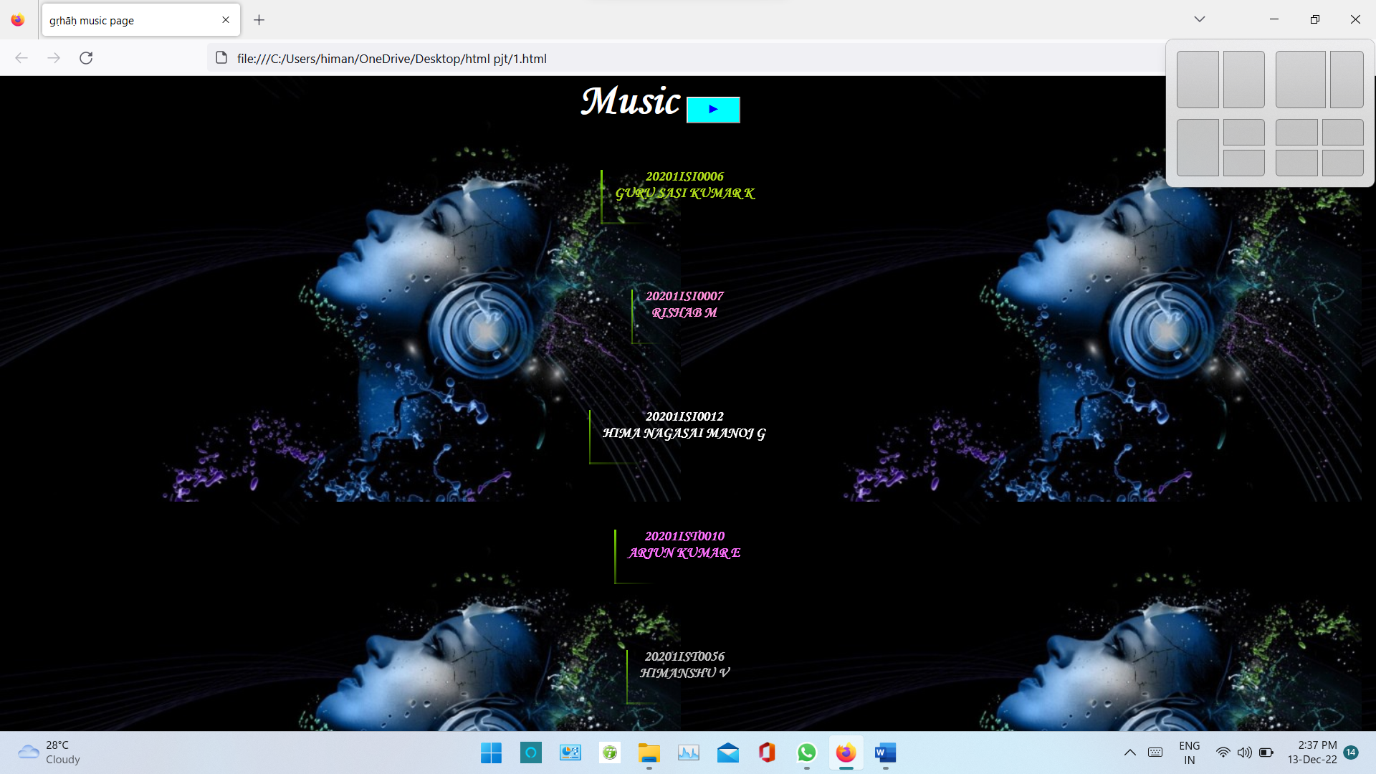

**2.HTML**

<html>

<title>

gṛhāḥ music page

</title>

<frameset rows="30%,*%">

<frame name="top" src="[4.html](view-source:file:///C:/Users/himan/OneDrive/Desktop/html%20pjt/4.html)" name="topframe">

<frameset cols="25%,*" >

<frame name="left" src="[5.html](view-source:file:///C:/Users/himan/OneDrive/Desktop/html%20pjt/5.html)" name="leftframe">

<frame src="[6.html](view-source:file:///C:/Users/himan/OneDrive/Desktop/html%20pjt/6.html)" height="100%"noresize name="rightframe">

</frameset>

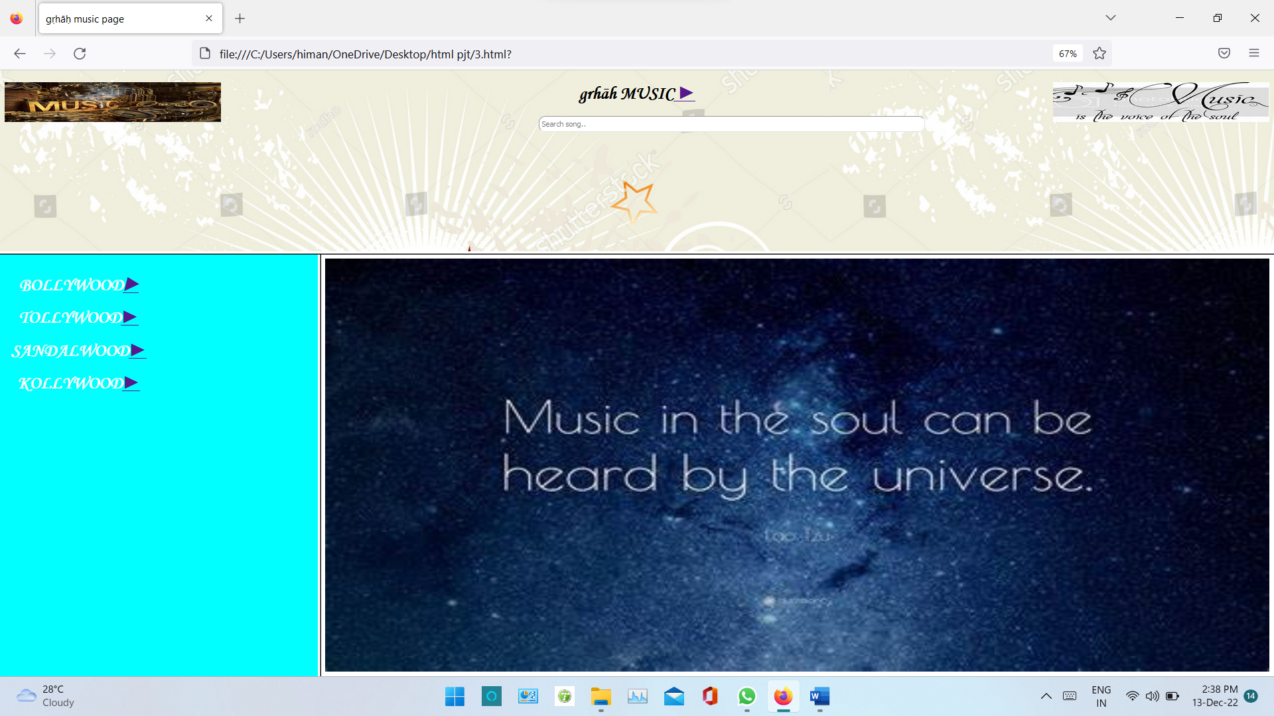

**3.HTML**

<!DOCTYPE html>

<html>

<head>

<title>

gṛhāḥ music page

</title>

<!-- linking the stylesheet(CSS) -->

<link rel="stylesheet" type="text/css" href="[4.css](view-source:file:///C:/Users/himan/OneDrive/Desktop/html%20pjt/4.css)">

</head>

<p> <img src="[m7.jpeg](view-source:file:///C:/Users/himan/OneDrive/Desktop/html%20pjt/m7.jpeg)" style="float:right;width:392px;height:72px;"></p>

<p><img src="[m.jpg](view-source:file:///C:/Users/himan/OneDrive/Desktop/html%20pjt/m.jpg)" style="float:left;width:392px;height:72px;"></p>

<body background="[m1.jpg](view-source:file:///C:/Users/himan/OneDrive/Desktop/html%20pjt/m1.jpg)">

<center>

<h1><k>grhāh MUSIC<a href="[11.html](view-source:file:///C:/Users/himan/OneDrive/Desktop/html%20pjt/11.html)" target="rightframe"> &#9658;</a></h1>

<!-- input tag -->

<align="middlie">

<input id="searchbar" onkeyup="search_animal()" type="text"

name="search" placeholder="Search song..">

<!-- ordered list -->

<ul id='list'>

<li class="song"><img src="[sama.jpeg](view-source:file:///C:/Users/himan/OneDrive/Desktop/html%20pjt/sama.jpeg)" width="30px">Samajavaragamana<a href="[8a.html](view-source:file:///C:/Users/himan/OneDrive/Desktop/html%20pjt/8a.html)" target="rightframe">&#9654;</a></li>

<li class="song">Dum dare<a href="[dum.mp4](view-source:file:///C:/Users/himan/OneDrive/Desktop/html%20pjt/dum.mp4)" target="rightframe">&#9654;</a></li>

<li class="song">Mammakutty<a href="[mam.mp3](view-source:file:///C:/Users/himan/OneDrive/Desktop/html%20pjt/mam.mp3)" target="rightframe">&#9654;</a></li>

<li class="song">Teri Meri Prem Kahani<a href="[teri.mp3](view-source:file:///C:/Users/himan/OneDrive/Desktop/html%20pjt/teri.mp3)" target="rightframe">&#9654;</a></li>

<li class="song">Gundellona<a href="[gun.mp3](view-source:file:///C:/Users/himan/OneDrive/Desktop/html%20pjt/gun.mp3)" target="rightframe">&#9654;</a></li>

<li class="song">I Wanna Fly<a href="[iwa.mp3](view-source:file:///C:/Users/himan/OneDrive/Desktop/html%20pjt/iwa.mp3)" target="rightframe">&#9654;</a></li>

<li class="song">Toofan<a href="[too.mp3](view-source:file:///C:/Users/himan/OneDrive/Desktop/html%20pjt/too.mp3)" target="rightframe">&#9654;</a></li>

<li class="song">Ra Ra Rakkamma<a href="[ra ra.mp3](view-source:file:///C:/Users/himan/OneDrive/Desktop/html%20pjt/ra%20ra.mp3)" target="rightframe">&#9654;</a></li>

<li class="song">Ranjithame<a href="[ran.mp3](view-source:file:///C:/Users/himan/OneDrive/Desktop/html%20pjt/ran.mp3)" target="rightframe">&#9654;</a></li>

<li class="song">Oo Shivangi<a href="[oo.mp3](view-source:file:///C:/Users/himan/OneDrive/Desktop/html%20pjt/oo.mp3)" target="rightframe">&#9654;</a></li>

<li class="song">Kesaria<a href="[Kes.mp3](view-source:file:///C:/Users/himan/OneDrive/Desktop/html%20pjt/Kes.mp3)" target="rightframe">&#9654;</a></li>

</ol>

<!-- linking javascript -->

<script src="[4.js](view-source:file:///C:/Users/himan/OneDrive/Desktop/html%20pjt/4.js)"></script>

</body>

</html>

**3.CSS**

#searchbar{

margin-left: 15%;

padding:5px;

border-radius: 10px;

position: relative;

}

k{

font-family:Monotype Corsiva;

}

input[type=text] {

width: 30%;

padding: 20px;

-webkit-transition: width 0.15s ease-in-out;

transition: width 0.15s ease-in-out;

}

/* When the input field gets focus,

change its width to 100% */

input[type=text]:focus {

width: 60%;

height: 5%;

}

#list{

opacity: 0;

font-family:Monotype Corsiva;

font-size: 1.5em;

margin-left: 90px;

text-shadow: 1px 1px #30804b;

}

/* When the list field gets searched,

change its opacity to 100% */

list:focus{

opacity: 1;

}

#list:hover{

opacity: 0.5;

}

**3.JSS**

// JavaScript code

function search_animal() {

let input = document.getElementById('searchbar').value

input=input.toLowerCase();

let x = document.getElementsByClassName('song');

for (i = 0; i < x.length; i++) {

if (!x[i].innerHTML.toLowerCase().includes(input)) {

x[i].style.display="none";

}

else {

x[i].style.display="list-item";

}

}

}

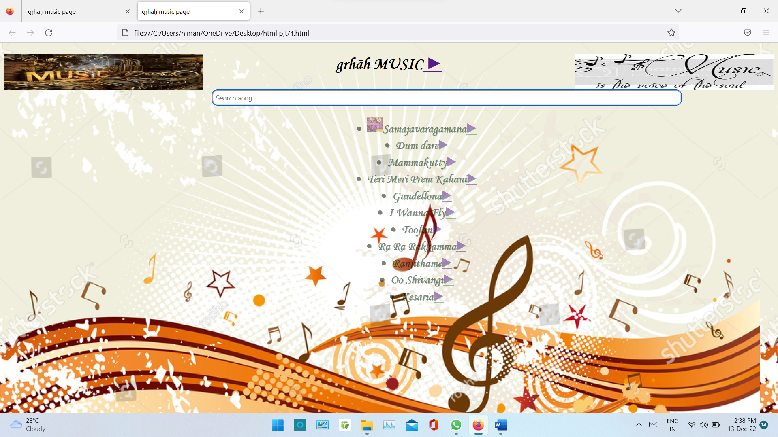

**4.HTML**

<html>

<title>

grhāh music page

</title>

<body bgcolor="aqua">

<style>

i{

padding: 20px;

font-family:Monotype Corsiva;

}

</style>

<table >

<tr>

<th><b><i><center><font color="white" size="6ppx">BOLLYWOOD<a href="[7.html](view-source:file:///C:/Users/himan/OneDrive/Desktop/html%20pjt/7.html)" target="rightframe">&#9654;</a>

</th>

</tr>

<tr>

<th><i><font color="white" size="6ppx">TOLLYWOOD<a href="[8.html](view-source:file:///C:/Users/himan/OneDrive/Desktop/html%20pjt/8.html)" target="rightframe">&#9658;</a></th>

</tr>

<tr>

<th><i><center><font color="white" size="6ppx">SANDALWOOD<a href="[9.html](view-source:file:///C:/Users/himan/OneDrive/Desktop/html%20pjt/9.html)" target="rightframe">&#9658;</a></th>

</tr>

<tr>

<th><i><font color="white" size="6ppx">KOLLYWOOD<a href="[10.html](view-source:file:///C:/Users/himan/OneDrive/Desktop/html%20pjt/10.html)" target="rightframe">&#9658;</a></th>

</tr>

<table>

</html>

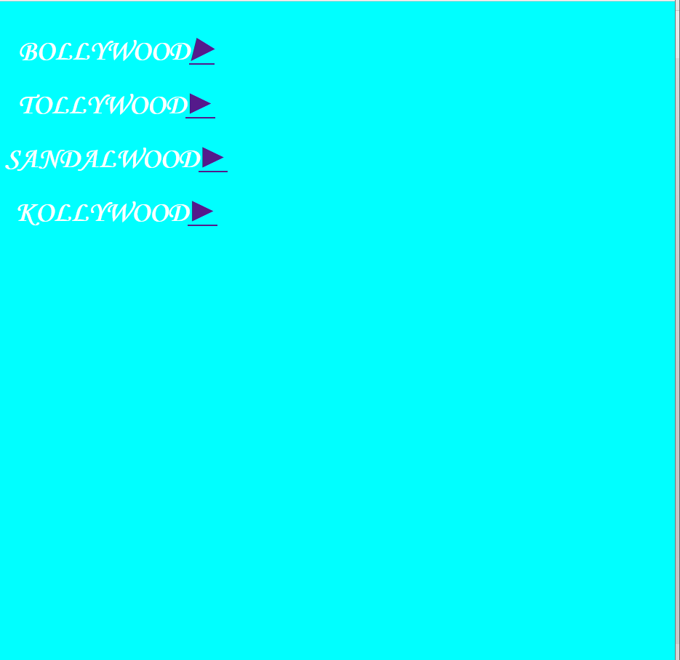

**5.HTML**

<html>

<boody>

<img src="[m2.jpeg](view-source:file:///C:/Users/himan/OneDrive/Desktop/html%20pjt/m2.jpeg)" width="100%" height="100%">

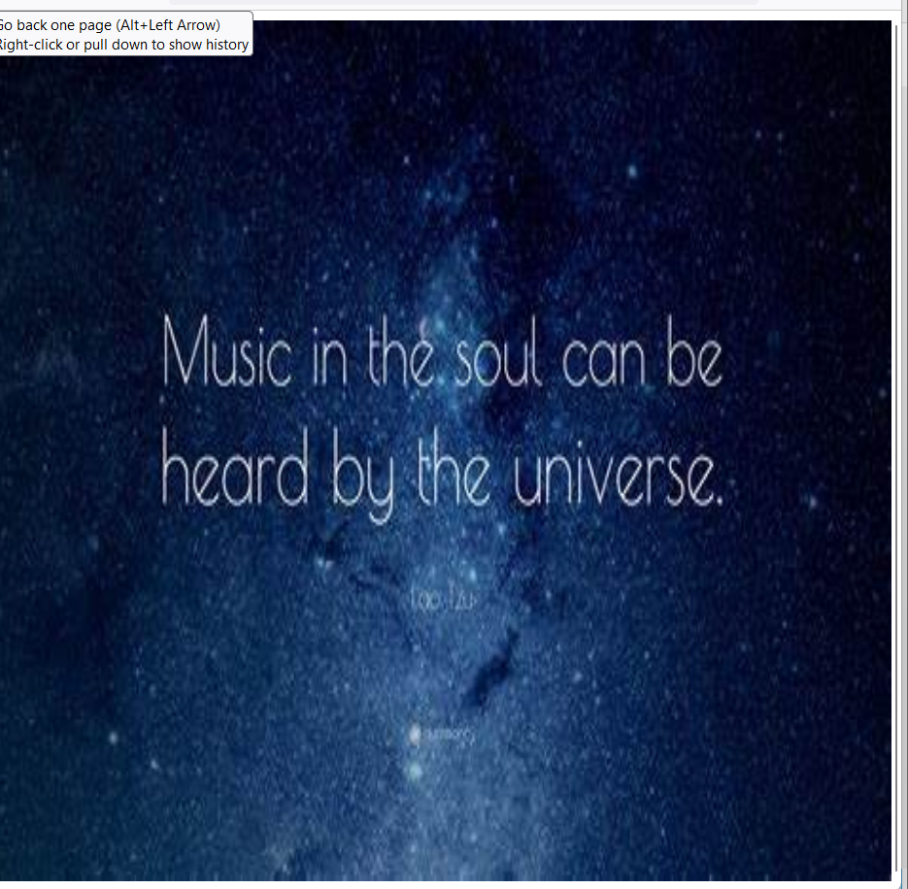

**6.HTML**

<html>

<title>

gṛhāḥ music page

</title>

<body bgcolor="yellow">

<meta name="viewport" content="width=device-width, initial-scale=1">

<style>

body {

font-family: Monotype Corsiva;

}

.flip-card {

background-color: transparent;

width: 300px;

height: 300px;

perspective: 1000px;

}

.flip-card-inner {

position: relative;

width: 100%;

height: 100%;

text-align: center;

transition: transform 0.6s;

transform-style: preserve-3d;

box-shadow: 0 4px 8px 0 rgba(0,0,0,0.2);

}

.flip-card:hover .flip-card-inner {

transform: rotateY(180deg);

}

.flip-card-front, .flip-card-back {

position: absolute;

width: 100%;

height: 100%;

-webkit-backface-visibility: hidden;

backface-visibility: hidden;

}

.flip-card-front {

background-color: #bbb;

color: black;

}

.flip-card-back {

background-color: white;

color: white;

transform: rotateY(180deg);

}

</style>

</head>

<body>

<center>

<h1><font size="7ppx" color="blue">🎶🎶 Bollywood Music 🎶🎶</h1>

<center>

<div class="flip-card">

<div class="flip-card-inner">

<div class="flip-card-front">

<img src="[b.jpeg](view-source:file:///C:/Users/himan/OneDrive/Desktop/html%20pjt/b.jpeg)" style="width:300px;height:300px;">

</div>

<div class="flip-card-back">

<img src="[m1.png](view-source:file:///C:/Users/himan/OneDrive/Desktop/html%20pjt/m1.png)" style="width:300px;height:300px;">

</div>

</div>

</div>

<table>

<tr>

<th><font size="6ppx">Teri Meri Prem Kahani<a href="[Teri.mp3](view-source:file:///C:/Users/himan/OneDrive/Desktop/html%20pjt/Teri.mp3)">&#9658;</a></th>

<tr>

<th><font size="6ppx">Kesaria<a href="[kes.mp3](view-source:file:///C:/Users/himan/OneDrive/Desktop/html%20pjt/kes.mp3)">&#9658;</a></th>

<tr>

<th><font size="6ppx">Jab Tak<a href="[jab.mp3](view-source:file:///C:/Users/himan/OneDrive/Desktop/html%20pjt/jab.mp3)">&#9658;</a></th>

</body>

</html>

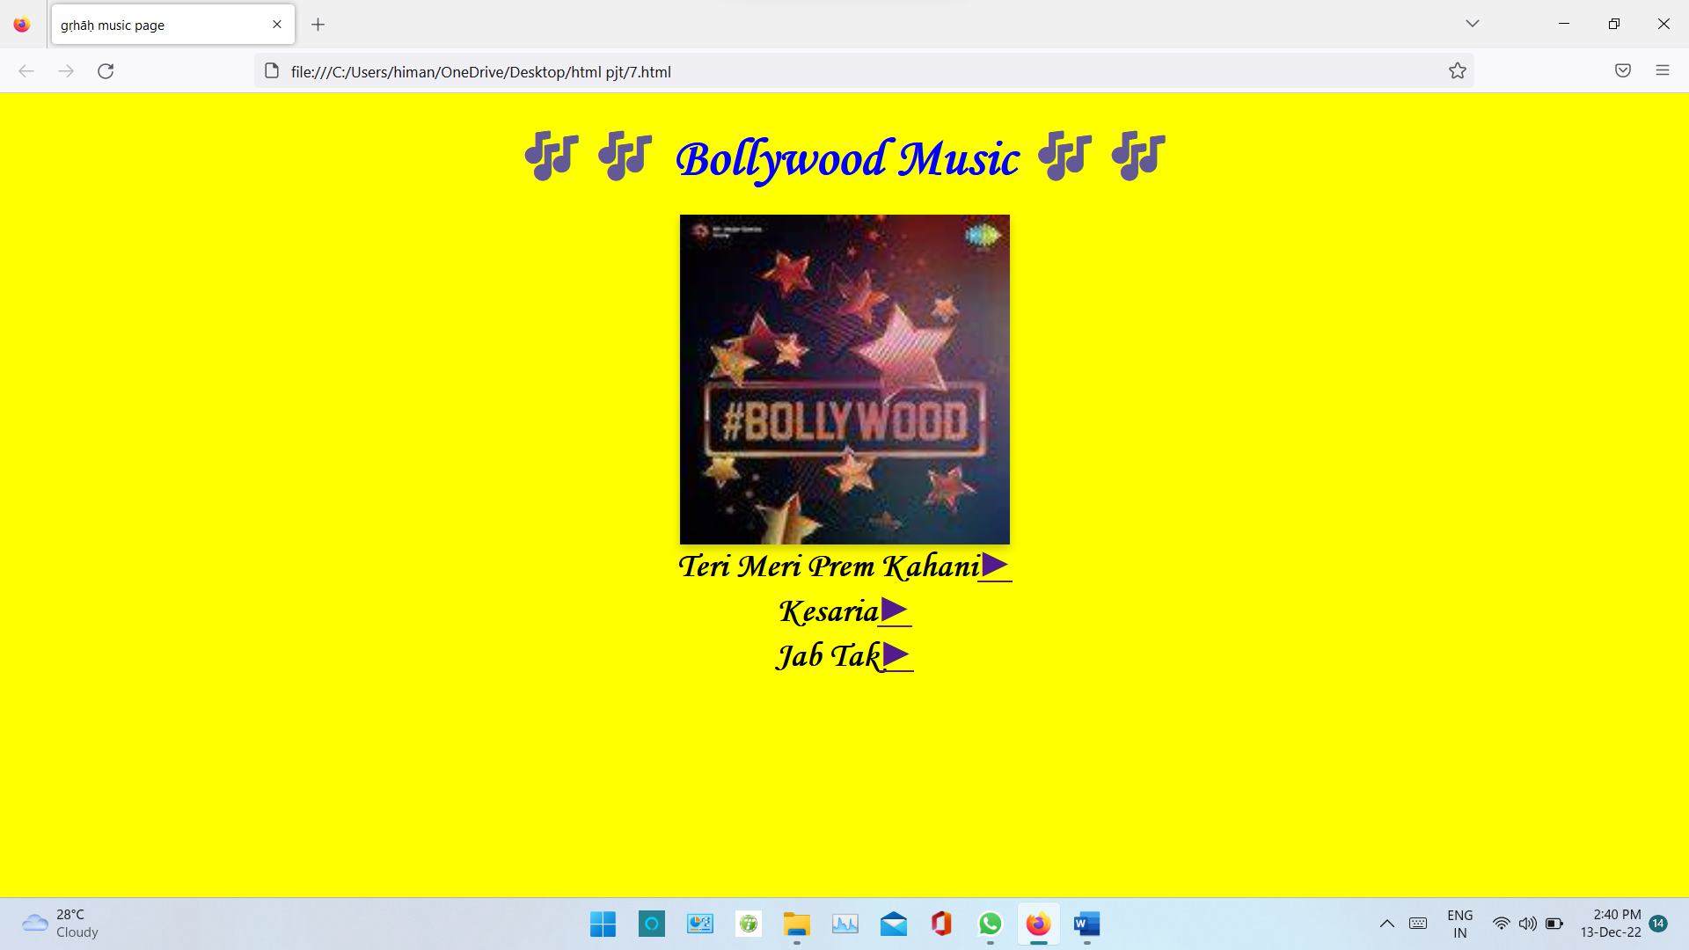

**7.HTML**

<html>

<title>

gṛhāḥ music page

</title>

<body bgcolor="#FF9900" width="100%" height="100%">

<meta name="viewport" content="width=device-width, initial-scale=1">

<style>

body {

font-family: Monotype Corsiva;

}

.flip-card {

background-color: transparent;

width: 300px;

height: 300px;

perspective: 1000px;

}

.flip-card-inner {

position: relative;

width: 100%;

height: 100%;

text-align: center;

transition: transform 0.6s;

transform-style: preserve-3d;

box-shadow: 0 4px 8px 0 rgba(0,0,0,0.2);

}

.flip-card:hover .flip-card-inner {

transform: rotateY(180deg);

}

.flip-card-front, .flip-card-back {

position: absolute;

width: 100%;

height: 100%;

-webkit-backface-visibility: hidden;

backface-visibility: hidden;

}

.flip-card-front {

background-color: #bbb;

color: black;

}

.flip-card-back {

background-color: ;

color: white;

transform: rotateY(180deg);

}

</style>

</head>

<body>

<center>

<h1><font size="7ppx" color="red">🎶🎶 Tollywood Music 🎶🎶</h1>

<center>

<div class="flip-card">

<div class="flip-card-inner">

<div class="flip-card-front">

<img src="[t2.jpeg](view-source:file:///C:/Users/himan/OneDrive/Desktop/html%20pjt/t2.jpeg)" style="width:300px;height:300px;">

</div>

<div class="flip-card-back">

<img src="[t.png](view-source:file:///C:/Users/himan/OneDrive/Desktop/html%20pjt/t.png)" style="width:300px;height:300px;">

</div>

</div>

</div>

<table>

<tr>

<th><font size="6px">Samajavaragamana<a href="[8a.html](view-source:file:///C:/Users/himan/OneDrive/Desktop/html%20pjt/8a.html)">&#9658;</a></th>

</tr>

<tr>

<th><font size="6px">I Wanna Fly<a href="[iwa.mp3](view-source:file:///C:/Users/himan/OneDrive/Desktop/html%20pjt/iwa.mp3)">&#9658;</a></th>

</tr>

<tr>

<th><font size="6px">Gundellona<a href="[gun.mp3](view-source:file:///C:/Users/himan/OneDrive/Desktop/html%20pjt/gun.mp3)">&#9658;</a></th>

</tr>

</body>

</html>

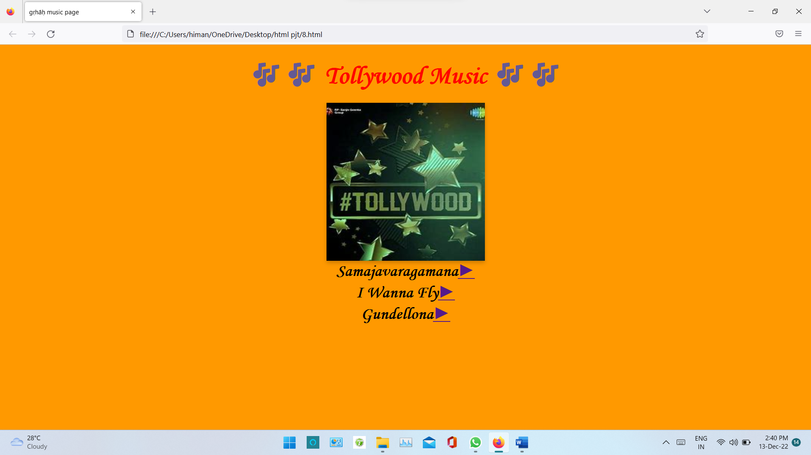

**8.HTML**

<html>

<body bgcolor="#FF0066" width="100%" height="100%">

<meta name="viewport" content="width=device-width, initial-scale=1">

<style>

body {

font-family: Monotype Corsiva;

}

.flip-card {

background-color: transparent;

width: 300px;

height: 300px;

perspective: 1000px;

}

.flip-card-inner {

position: relative;

width: 100%;

height: 100%;

text-align: center;

transition: transform 0.6s;

transform-style: preserve-3d;

box-shadow: 0 4px 8px 0 rgba(0,0,0,0.2);

}

.flip-card:hover .flip-card-inner {

transform: rotateY(180deg);

}

.flip-card-front, .flip-card-back {

position: absolute;

width: 100%;

height: 100%;

-webkit-backface-visibility: hidden;

backface-visibility: hidden;

}

.flip-card-front {

background-color: #bbb;

color: black;

}

.flip-card-back {

background-color: ;

color: white;

transform: rotateY(180deg);

}

</style>

</head>

<body>

<center>

<h1><font size="7ppx" color="aqua">🎶🎶 Sandalwood Music 🎶🎶</h1>

<center>

<div class="flip-card">

<div class="flip-card-inner">

<div class="flip-card-front">

<img src="[s.jpg](view-source:file:///C:/Users/himan/OneDrive/Desktop/html%20pjt/s.jpg)" style="width:300px;height:300px;">

</div>

<div class="flip-card-back">

<img src="[m.jpeg](view-source:file:///C:/Users/himan/OneDrive/Desktop/html%20pjt/m.jpeg)" style="width:300px;height:300px;">

</div>

</div>

</div>

<table>

<tr>

<th><font size="6px">Dum Dare<a href="[dum.mp4](view-source:file:///C:/Users/himan/OneDrive/Desktop/html%20pjt/dum.mp4)">&#9658;</a></th>

</tr>

<tr>

<th><font size="6px">Toofan<a href="[too.mp3](view-source:file:///C:/Users/himan/OneDrive/Desktop/html%20pjt/too.mp3)">&#9658;</a></th>

</tr>

<tr>

<th><font size="6px">Ra Ra Rakkamma<a href="[ra ra.mp3](view-source:file:///C:/Users/himan/OneDrive/Desktop/html%20pjt/ra%20ra.mp3)">&#9658;</a></th>

</tr>

</body>

</html>

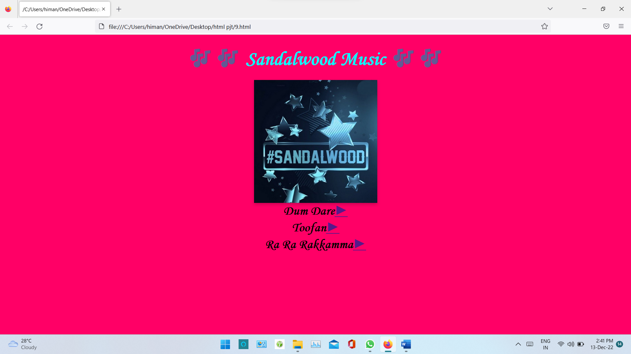

**9.HTML**

<html>

<body bgcolor="#66FF66" width="100%" height="100%">

<meta name="viewport" content="width=device-width, initial-scale=1">

<style>

body {

font-family: Monotype Corsiva;

}

.flip-card {

background-color: transparent;

width: 300px;

height: 300px;

perspective: 1000px;

}

.flip-card-inner {

position: relative;

width: 100%;

height: 100%;

text-align: center;

transition: transform 0.6s;

transform-style: preserve-3d;

box-shadow: 0 4px 8px 0 rgba(0,0,0,0.2);

}

.flip-card:hover .flip-card-inner {

transform: rotateY(180deg);

}

.flip-card-front, .flip-card-back {

position: absolute;

width: 100%;

height: 100%;

-webkit-backface-visibility: hidden;

backface-visibility: hidden;

}

.flip-card-front {

background-color: #bbb;

color: black;

}

.flip-card-back {

background-color: ;

color: white;

transform: rotateY(180deg);

}

</style>

</head>

<body>

<center>

<h1><font size="7ppx" color="red">🎶🎶 Kollywood Music 🎶🎶</h1>

<center>

<div class="flip-card">

<div class="flip-card-inner">

<div class="flip-card-front">

<img src="[k.jpg](view-source:file:///C:/Users/himan/OneDrive/Desktop/html%20pjt/k.jpg)" style="width:300px;height:300px;">

</div>

<div class="flip-card-back">

<img src="[m5.jpeg](view-source:file:///C:/Users/himan/OneDrive/Desktop/html%20pjt/m5.jpeg)" style="width:300px;height:300px;">

</div>

t

</div>

</div>

<table>

<tr>

<th><font size="6px">Ranjithame<a href="[ran.mp3](view-source:file:///C:/Users/himan/OneDrive/Desktop/html%20pjt/ran.mp3)">&#9658;</a></th>

</tr>

<tr>

<th><font size="6px">Shivangi<a href="[oo.mp3](view-source:file:///C:/Users/himan/OneDrive/Desktop/html%20pjt/oo.mp3)">&#9658;</a></th>

</tr>

<tr>

<th><font size="6px">Mamakutty<a href="[mam.mp3](view-source:file:///C:/Users/himan/OneDrive/Desktop/html%20pjt/mam.mp3)">&#9658;</a></th>

</tr>

</body>

</html>

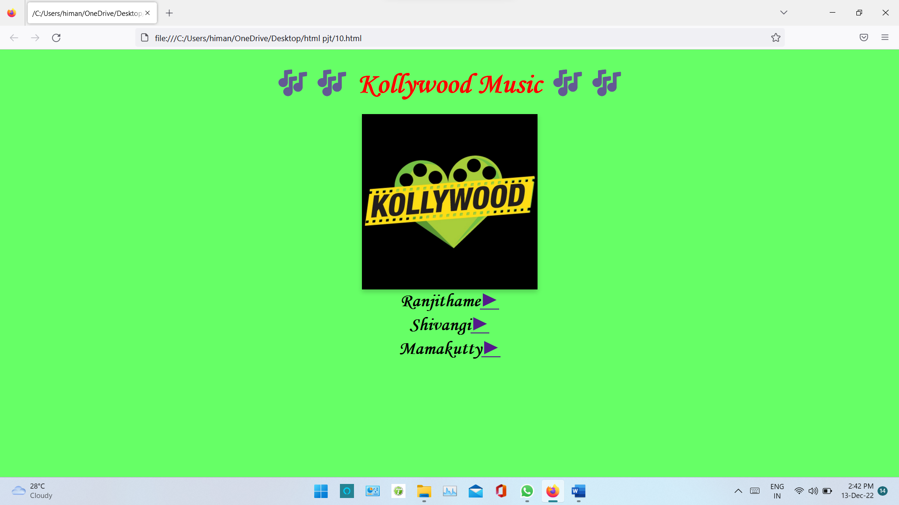

**7A.HTML**

<html>

<body bgcolor="black">

<style>

.services-container {

max-width: 100%;

height: 200%;

margin: 10 auto;

color: #e0e2db;

background: url(sama.jpeg);

background-position:BOTTOM;

background-size: cover;

background-repeat: repeat;

}

.service-item {

overflow: hidden;

position: full;

padding: 70px;

}

.service-item-black {

background: linear-gradient(

rgba(0, 0, 0, 0.7),

rgba(0, 0, 0, 0.7)

);

}

.front-text {

text-align: center;

transition: transform 30s;

font-famiy: Monotype Corsiva;

}

.back-text {

position: relative;

bottom: -30em;

width: 75%;

height: 100%;

margin: 0 auto;

height: 45%;

transition: bottom 75s;

padding: 35px 0;

}

.back-text h1 {

margin-bottom: 20px;

}

.back-text button {

margin-top: 100px;

padding: 10px 20px;

background: transparent;

border: 10px solid #30804b;

font-size: 20px;

color: #30804b;

}

.back-text button:hover {

background-color: #30804b;

color: #191716;

}

.service-item:hover .front-text {

transform: translateY(-200px);

}

.service-item:hover .back-text {

bottom: 1550;

}

</style>

</head>

<body>

<div class="services-container">

<article class="service-item

service-item-black">

<div class="front-text">

<h1><i><font size="10ppx">SAMAJAVARAGAMANA</h1>

</div>

<div class="back-text">

<h1>LYRICS</h1>

<p>(lyrics aren't synced )<p>

<p><font size="10ppx"><center>

Nee kaallani pattuku vadalanannavi

</br>

Choode naa kallu

</br>

Aa choopulanalla thokkuku vellaku

</br>

Dayaledha asalu

</br>

humming

</br>

Nee kaallani pattuku vadalanannavi

</br>

Choode naa kallu

</br>

Aa choopulanalla thokkuku vellaku

</br>

Dayaledha asalu

</br>

Nee kallaki kaavaali

</br>

Kaasthaaye kaatukala naa kalalu

</br>

Nuvvu nulumuthunte yerraga kandhi

</br>

Chindhene segalu

</br>

Naa oopiri gaaliki

</br>

Uyyaalalooguthu unte mungurulu

</br>

Nuvvu nettesthe ela nittoorchavatte

</br>

Nishtoorapu vilavilalu

</br>

Samajavaragamana

</br>

Ninu choosi aaga galana

</br>

Manasu meeda vayasukunna

</br>

Adupu cheppa thaguna

</br>

Samajavaragamana

</br>

Ninu choosi aaga galana

</br>

Manasu meeda vayasukunna

</br>

Adupu cheppa thaguna

</br>

Mallela maasama, Manjula haasama

</br>

Prathi malupulona yeduru padina

</br>

Vannela vanamaa

</br>

Virisina pinchamaa, Virula prapanchama

</br>

Ennenni vanne chinnelante

</br>

Ennela vashama

</br>

Arey naa gaale thagilina

Naa neede thariminaa

Vulakavaa, palakavaa bhaamaa

Entho brathimaalina

Inthena anganaa

Madhini meetu madhuramaina

Manavini vinumaa

Samajavaragamana

Ninu choosi aaga galana

Manasu meeda vayasukunna

Adupu cheppa thaguna

Samajavaragamana

Ninu choosi aaga galana

Manasu meeda vayasukunna

Adupu cheppa thaguna

</br>

Nee kaallani pattuku vadalanannavi

Choode naa kallu

Aa choopulanalla thokkuku vellaku

Dayaledha asalu

Nee kallaki kaavaali

Kaasthaaye kaatukala naa kalalu

Nuvvu nulumuthunte yerraga kandhi

Chindhene segalu

</p>

</div>

</article>

</div>

<center>

<embed src="[sama.mp3](view-source:file:///C:/Users/himan/OneDrive/Desktop/html%20pjt/sama.mp3)">

</body>

</html>

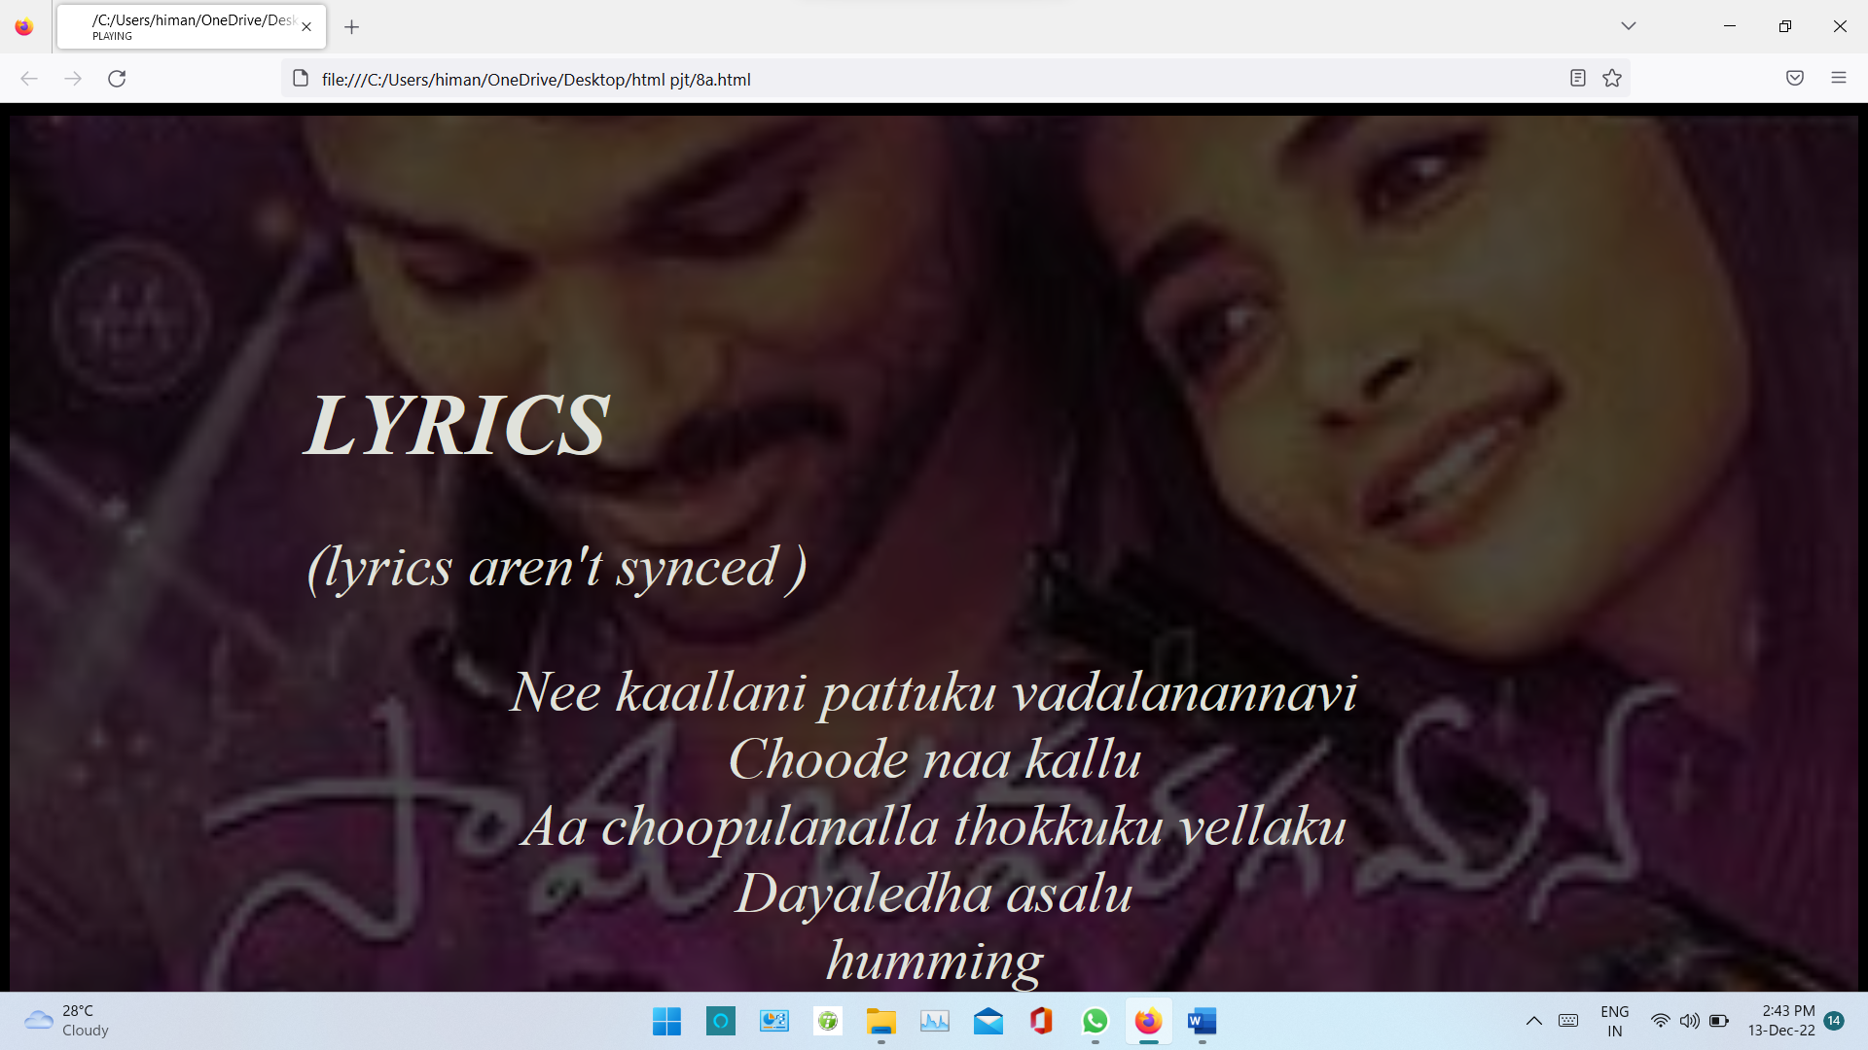

**10.HTML**

<html>

<body bgcolor="aqua">

<center>

<table>

<tr>

<th><i><font size="21ppx">1.html</font></th>

<tr>

<th><i><img src=[1.jpg](view-source:file:///C:/Users/himan/OneDrive/Desktop/html%20pjt/1.jpg)></th>

</tr>

<tr>

<th><i><font size="21ppx">3.html</th>

<tr>

<th><i><img src=[3.png](view-source:file:///C:/Users/himan/OneDrive/Desktop/html%20pjt/3.png)></th>

<tr>

</tr>

<tr>

<th><i><font size="21ppx">4.html</th>

<tr>

<th><i><img src=[4.png](view-source:file:///C:/Users/himan/OneDrive/Desktop/html%20pjt/4.png)></th>

</tr>

<tr>

<th><i><font size="21ppx">5.html</th>

<tr>

<th><i><img src=[5.png](view-source:file:///C:/Users/himan/OneDrive/Desktop/html%20pjt/5.png)></th>

</tr>

<tr>

<th><i><font size="21px">6.html</th>

<tr>

<th><i><img src=[6.png](view-source:file:///C:/Users/himan/OneDrive/Desktop/html%20pjt/6.png)></th>

</tr>

<tr>

<th><font size="21ppx">7.html,8.html,9.html,,10.html all are similar</th>

<tr>

<th><i><img src=[7.png](view-source:file:///C:/Users/himan/OneDrive/Desktop/html%20pjt/7.png)></th>

</tr>

<tr>

<th><i><font size="21ppx">8a.html</th>

<tr>

<th><i><img src=[8a.png](view-source:file:///C:/Users/himan/OneDrive/Desktop/html%20pjt/8a.png)></th>

</tr>

<tr>

<th><i><font size="21ppx">11.html</th>

<tr>

<th><i><img src=[11.png](view-source:file:///C:/Users/himan/OneDrive/Desktop/html%20pjt/11.png)></th>

</tr>

</html>

